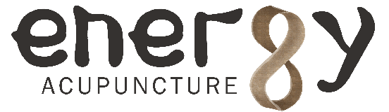**use various treatment methods**

**to restore and maintain health.**

**ACUPUNCTURE –**Tiny, disposable, sterile needles placed gently into specific acupuncture points.

**Herbs –** Oriental herbal medicine draws from a pharmacopoeia of thousands of herbs for specific conditions.

**Teas**-Specific Korean Traditional teas used to strengthen, rebuild and balance the body.

**Moxibustion**-The dried leaf of *mugwort* is rolling into a stick or placed on the end of needles, then burned as a warming therapy during treatment.

**Electro-acupuncture**-Acupuncture points are stimulated using a safe, gentle, electrical current.

**Cupping**-Using glass cups to create a vacuum in order to increase warmth and circulation. **(**Cupping can result in temporary marks and bruises on your skin. Some cupping methods use a flame on the glass before starting.)

**Gwa Sha** – A gentle scraping of the skin surface using a Gwa Sha tool to increase circulation of Qi and blood.

**Ear Acupuncture** – stimulating certain points on the auricle with seeds or needles.